UPDATE

Happy Thanksgiving!
Annual General Meeting:
Our Sept 24 AGM was a great success, with 42 attendees and some great food!
Draft minutes are attached below.
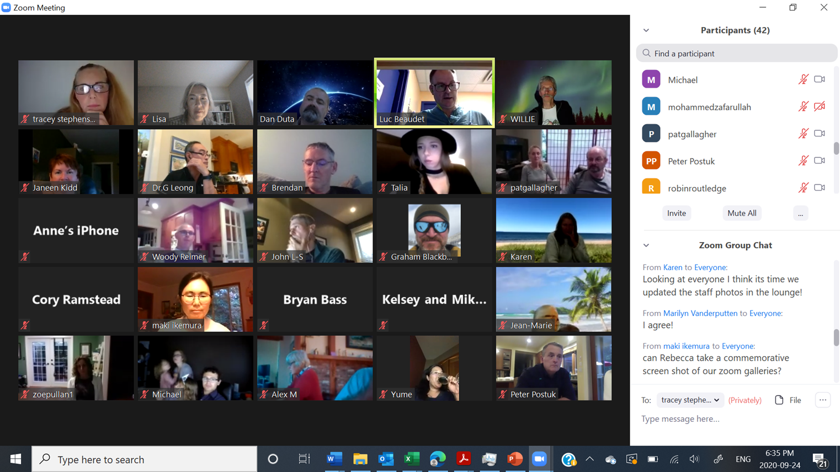
Our new Executive was approved at the meeting:
Dr. Brendan O’Malley  Co-Chair/President | Dr. Tracey Stephenson  Co-Chair/President/Communications | Dr. Susan Barr  Secretary-Treasurer | Dr. Christiaan Avenant  Director

So, welcome Christie! And, farewell to our now Past President Dr. Luc Beaudet (almost 3 years at the helm!) and to outgoing Director Dr. Alex Moll (a valued member in many of our committees from the beginning).
Also, welcoming John Lewis-Schneider to the CDMS team, for managing our finances; and thankyou to Jennifer Berg (departing) who has guided our finance/operations from CDMS inception!
CDMS Website
Check out our new website: https://www.cowichandoctors.ca
Highlights:
- Register for member access to documents including minutes, organizational structure and phone numbers, members directory and the Welcome/Goodbye and Congratulations section with bios. See the below attached two recent communications for more detail on registering for our website.
- CME events have their own subheading under events and news/ CME.
- Information on our Projects (including recent Covid work) is provided with a link to propose projects.
- Recruitment and Retention section: instead of continuing with a committee, we will have input from our Advisory Committee and continued admin support. Also provided is the new physician Welcome Package from the CVDFP, links to resources, and information re: our funding for recruitment dinners.
- The events and news page also has a link to the IH calendar which has all the IH linked events listed in a calendar format.
- We have simplified funding - check out the new guidelines (attached, and on the website under Project guidelines) to fund food, strategic planning and retreats.
Orthopedics
There have been a few changes in the orthopedic group - from staffing to how they are running referrals. See the attached letter and new central intake form.
DoBC survey reminder – Please complete by Oct 14
The annual membership survey for Doctors of BC was launched (Health Authority Engagement Survey) for completion September 14 – October 14, 2020. The email had come from HSO (Health Standards Organization) NOT Doctors of BC directly, and it has been sent to the email address Doctors of BC has on file for the member.
- GPs, Specialists, Division and MSA members all receive the survey if they are a Doctors of BC member. If physicians do not receive their survey, they may contact surveys@doctorsofbc.ca
- Your colleagues will have the opportunity this year to share their thoughts about COVID (2020) working at Island Health and also the workplace psych/physical safety questions.
- The email will have come from Health Standards Organization (HSO) NOT Doctors of BC directly. Search your email for: <surveyinstruments@healthstandardsorganization.ca> via research.net . If you require a new link, please contact Alanna Black at ablack@doctorsofbc.ca, who can facilitate this through HSO. Thank you very much for your help sharing and promoting this important survey!
Important Notes:
- Same core questions from past years (Work Life Pulse Tool). Second year with questions about Psychological and Physical Safety, including new opportunity for open-ended responses. New questions were added this year specifically in relation to COVID-19.
- Provincially, 26% of Doctors of BC members completed the survey last year (approx. 12,000 members in BC). On the Island, 574 physicians completed the survey last year. As of Oct 6, 33 CDH physicians have completed the survey; last year 46 had completed it. The Health Authorities across the province are very interested in the results and it is the opportunity to hear the physician voice.
- At least five survey respondents from a site are required to be included in the annual report. Below are links for previous site-level data:
  - 2016 data is found here on Page 28: Supplemental report. Note: This first year was not administered with HSO. 2016 did not have site-level data.
  - 2017 data is found here on Pages 28-35: Supplemental report
  - 2018 data is found here on Pages 40-50: Supplemental report
  - 2019 data is found here on Pages 46-57: Supplemental report

CME:
Quality Team Coaching for Rural BC
In Quality Team Coaching for Rural BC (QTC4RBC), rural healthcare teams work with a coach to identify values and priorities, develop collective and individual skills, and access resources to build a culture of safety, learning, and quality leading to positive patient and provider experiences and high-quality care. The program provides:
- A virtual workshop with an ICF-certified coach (six (6) two-hour modules);
- Up to four virtual team coaching sessions and up to three one-on-one coaching sessions for leadership;
- A concierge service linking your team to BC programs and resources;
- Up to $40,000 for further team educational opportunities or to cover expenses of a quality improvement project;
- Opportunity to work on a self-chosen quality project with mentorship from an advisor;
- Up to 21.75 Mainpro+ credits or 7.25 MOC Section 3 Simulation hours
Rural healthcare teams may apply – submissions from RSA A or B communities will be prioritized. At least one physician must be part of the application team (or 20% if the team is more than 8). Interprofessional and leadership participation in the program is encouraged. Apply by October 30.
Visit rccbc.ca or contact apeltonen@rccbc.ca for more information.

UPCOMING EVENTS:
We plan on organizing a dinner Zoom event with an interesting speaker…stay tuned for more information.
HOW CAN WE HELP?
Let us know if you need assistance – if not from us, then we will find out who to direct you to.
If you would like more information on anything in this Update – please email rsimmons@cowichandoctors.ca

This e-mail and any attachment(s) is for authorized use by the intended recipient(s) only. If you are not the intended recipient, you are hereby notified that any review, retransmission, conversion to hard copy, copying, circulation or any other use of this message and any attachments is strictly prohibited. If you are not the intended recipient, please notify the sender immediately and delete this e-mail and any attachment(s). Thank you.

